Cookie Step

Objective

An HTTP cookie (also called web cookie, Internet cookie, browser cookie, or simply cookie) is a small piece of data sent from a website and stored on the user's computer by the user's web browser while the user is browsing.

UI

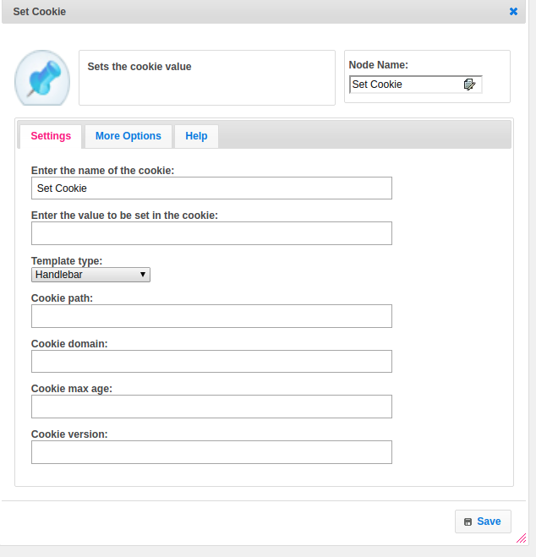

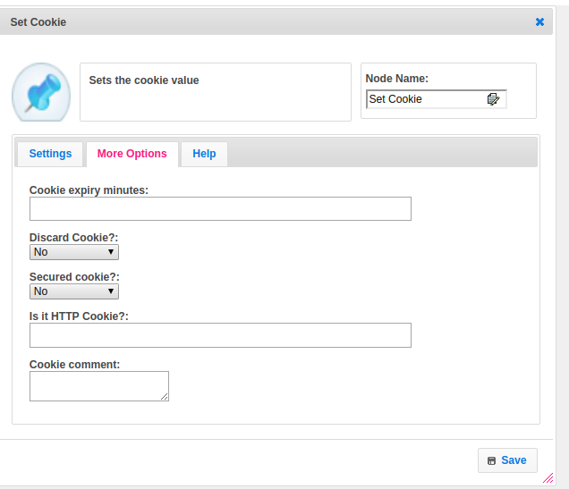

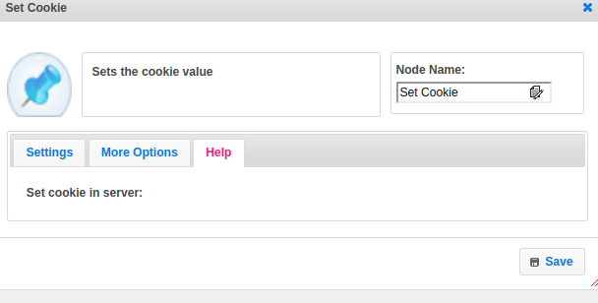

## Attributes

|  |  |
| --- | --- |
| **Attributes** | **Description** |
| **1. Enter the name of the cookie** | Name of the Cookie. |
| **2.Enter the value to be set in the cookie** | A cookie is often used to identify a user. A cookie is a small file that the server embeds on the user's computer. Each time the same computer requests a page with a browser, it will send the cookie too. |
| **3. Template type** | Value_type used to set the value type.  Value types are two types.  1.hb-HandleBars  2.ftl-Freemarker Template Language. |
| **4. Cookie path** | The cookie is usually stored by the browser, and then the cookie is sent with requests made to the same server inside a Cookie HTTP header. Additionally, restrictions to a specific domain and path can be set, limiting where the cookie is sent. |
| **5. Cookie domain** | The cookie domain is an important security feature, probably even more important than the secure flag. It tells the browser that this cookie must only be sent to matching domains. Matching, however, can happen in several ways. Perhaps domain is a bit of a misnomer: this can be any hostname, like appup.com |
| **6. Cookie max age** | A positive value indicates that the cookie will expire after that many seconds have passed. Note that the value is the maximum age when the cookie will expire, not the cookie's current age. A negative value means that the cookie is not stored persistently and will be deleted when the Web browser exits. |
| **7. Cookie version** | The version of HTTP state maintenance to which the cookie conforms. |
| **8. Cookie expiry minutes** | You can extend the life of a cookie beyond the current browser session by setting an expiration date and saving the expiry date within the cookie. This can be done by setting the 'expires' attribute to a date and time. |
| **9. Discard cookie** | True if the client is to discard the Cookie at the end of the current session, otherwise, false. The default is false. |
| **10. Secured Cookie** | Secure cookies are a type of HTTP cookie that has Secure attribute set, which limits the scope of the cookie to "secure" channels (where "secure" is defined by the user agent, typically a web browser).[1] When a cookie has the Secure attribute, the user agent will include the cookie in an HTTP request only if the request is transmitted over a secure channel.  The cookies could contain sensitive information such as passwords and credit card numbers. These are sent over an HTTP connection and are stored in web browsers as plain text, and so can be targeted and be used by attackers to steal the information stored in it. To prevent such information exposure cookies are secured with attributes. |
| **11. Is it HTTP cookie** | Provide the information about a cookie, like is it HTTP cookie or not |
| **12. Cookie comment** | The Comment interface represents textual notations within markup. |

## Executor Description:

Get all the information about a cookie from Cookie Step and create an object for the cookie and set every information provided by cookie step. Add the cookie information to the HttpResponse object.

## Resource:

Please find the following link to get more information about a cookie.

<https://tomcat.apache.org/tomcat-5.5-doc/servletapi/javax/servlet/http/Cookie.html>